

**Individual Learning Account:**

**modelling the impacts of possible policy interventions**

Funded by the European Union. Views and opinions expressed are however those of the author(s) only and do not necessarily reflect those of the European Union or the European Education and Culture Executive Agency (EACEA). Neither the European Union nor EACEA can be held responsible for them.

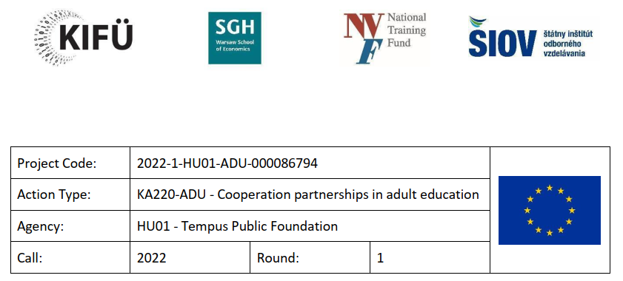

In order to improve the quality of adult learning and to increase the number of participants in adult learning, new financing concepts need to be developed, among other things. One of these new EU adult learning financing concepts is the Individual Learning Account (ILA), for which the Recommendation of 16 June 2022 described the framework but left the details of implementation to national competence. Accordingly, Member States can adjust the eligibility and funding parameters to activate groups with traditionally low participation in adult learning and reduce the risk of deadweight losses. The specific target group will depend on the specific objective: increasing overall participation, increasing participation in training that meets labour market needs, integration of immigrants, parents returning after childcare, involving elderly etc. When setting the level of public contribution, it should be borne in mind that differentiating the level of contribution according to the demographic characteristics of participants may lead to administrative complexity and thus create barriers to participation for groups with low participation rates in adult learning. The co-financing of activities (employer and individual contributions) and the definition of the learning content supported may vary from one Member State to another. All this shows that when implementing ILA, many aspects need to be considered together to detail the policy measure.

In the framework of our Erasmus+ international partnership project, we explored the concept of ILA from a data perspective. The cooperation of experts from the 4 Visegrad countries created the D-ILA data model to predict the possible impact of different policy concepts. It is important to note that throughout the project, we worked with realistic but not real data created by the expert team through editing. In the baseline version, the expert team determined to the best of their knowledge which individuals and training should be included in the model, and they also determined which training should be assigned to which individuals (training database). In simple terms, modelling seeks to answer questions of the "what if..." type, which in our case meant changing the input data along different policy concepts and then comparing the original (baseline) version with the output generated with the changed input data. The method of analysing the impact of different policy interventions and the differences between them allowed us to test the D-ILA data model. The model is therefore methodologically tested, but the D-ILA data model needs to be populated with real data in order to make real use of the resulting figures.

Due to the call for proposals (Erasmus+ KA2 Adult Education), in this data model we have described learners and training courses using competency frameworks describing transferable skills (CEFRL, DigComp, FinComp, EntreComp, LifeComp), and we have also tried to imagine training courses that develop skills belonging to several different frameworks at the same time (e.g. digital and green competence).The amount of funding (€400.000) did not allow for AI development, we were only able to demonstrate the relevance of modelling using existing solutions. By presenting professional concepts developed and tested by an international team of experts, we aim to highlight the usefulness of the D-ILA data model.

Some of the professional concepts tested were aimed at providing additional resources for the participation of a selected target group in adult learning. The D-ILA data model allowed the target group to be defined in several ways:

* by the competences preferred by the participants
* by highest level of education
* by participants' life situation category

The D-ILA data model was able to support targeting according to the interests of the learners. A good example of this is the significant increase in the public contribution for participants who wanted to participate in green skills training. As no other parameters were changed, the results obtained after running the AI showed the impact of the professional concept.

A similar approach was taken when our policy concept was that the state preferred to develop digital competences rather than green competences. (It is important to note that in the D-ILA data model, a strong emphasis is placed on training that develops several competences - for example green and digital competences - within one training.) Our policy approach of allocating additional public resources to the development of digital competences also differs from the previous one in that we have incorporated a significant increase in employer contributions for digital competence development. This is based on the premise that while green skills development is less relevant for an employer, digital skills development is in the employers' core interest - i.e. employers, not just the state, want to actively participate in the financing of digital skills training.

In another policy concept we have tried, public resources have been spent in a more focused way. Only and exclusively those who aimed to develop digital competences received public funding. At the same time, the policy concept did not exclude non-digital skills training from the system, as it did not eliminate financial contributions from employers and individuals.

Target groups can also be formed by differentiation according to the highest level of education. Compared to the baseline, the D-ILA data model has been used to test the case where those with tertiary education are not subsidised by the state - assuming that they have the resources to participate in adult learning without state support. In this case, our professional approach did not imply a resource extraction, as the public resources taken away from those with tertiary education were fully distributed among those without tertiary education.

The third way of creating a target group – provided to users by the D-ILA data model – was based on the classification of participants into life situation categories. In this professional concept, the training of NEET young people is financed by other means outside the ILA framework, and the public support initially signed for them was therefore distributed among the unemployed participants and the effectiveness of the support was tested this way.

The D-ILA data model was also tested in a case where significant additional public resources were allocated to the most deprived compared to the baseline, i.e. here the focus was not on reallocating public resources. Here too, we assessed the need according to the living situation category of the participants.

In addition to policy concepts based on target group differentiation, we also tested economic cost-benefit policy concepts using the D-ILA data model. One of these was to make it a condition of state aid that the learner should also contribute to the financing of their own training – and this was compulsory. In other words, the condition for state aid was an individual contribution. After various considerations and lengthy discussions, it was decided that the compulsory contribution should be 20%. In another case, we tested the effects of a compulsory contribution not only from the individual but also from the employer. And there was also a policy concept where we waived the compulsory co-payment for participants in certain target groups (in previous versions we gave additional state support on a means-tested basis, in which case the cost reduction was for the most deprived).

The policy concepts presented are based on different guidelines. However, the applicability of the D-ILA data model is further enhanced by the fact that a policy concept can be tested with different parameters. By not only modelling the 20% co-payment in the policy concept described above, but also calculating the result with different % ratios, we can compare the different impacts and, if necessary, make a better decision using the D-ILA data model.

The EU concept of ILA assumes that funding is also an incentive. This was also tested using the D-ILA data model: only participants who did not have personal learning objectives received public funding. The other "motivated" participants could only use individual or employer resources.

The policy concept of giving accredited training a greater role in the D-ILA data model is intended to improve the quality of optional training. This has been achieved by reducing the price of accredited training, partly departing from the ILA concept, thereby increasing the likelihood that cheaper training will be offered to a greater number of participants in the D-ILA data model.

This example illustrates that even an unconventional approach can produce good results – it is just that this should be verified by modelling prior to implementation. (The D-ILA data model is of course not a complete modelling system in its current form and further development is needed to apply it in real-life contexts.)

Another interesting approach is the policy concept that favours the provision of a particularly broad range of training. In this case, we have examined the effects of expanding the supply of training by offering training that is relatively inexpensive and can be relevant to a wide range of trainees.

The next policy concept intervened in the supply of training by modularising courses and analysing its effects. This aimed to halve the time spent on learning, reduce costs and reduce the number of competences that the course develops. The feasibility study carried out earlier in the project confirmed the validity of this concept, as there is a growing demand for short and focused modular adult learning courses to replace traditional adult learning courses.

One group of policy concepts created by our team of experts focused on the fact that state aid was not linked to a target group or any other condition, but was essentially treated as a benefit as a citizen's right. Thus, the policy concept set a baseline where all participants, without exception, received the same amount of public assistance, while the amount of employer subsidies and individual contributions remained unchanged.

In the next step of the modelling, we made changes to the input data such that the ILA concept was reduced to exclusive state support, i.e. all employer and participant financial contributions were set to 0 in the D-ILA data model. With this occupational concept, we modelled the effects of a significant resource withdrawal. Within the impacts, we have paid particular attention to how these impacts are felt by the NEET and the low-skilled. We also tried a less severe version of the resource extraction, where we "only" reduced the contribution of participants to 0, while imposing a mandatory contribution for employers.

The issue of the quality of training has been raised several times in the policy concepts. In addition to state funding as a citizen's right, we have also tried out the option whereby the same amount of state funding for all can only be spent on accredited training. This is a significant conceptual change, since in the basic version state funding was still freely spendable, whereas in this case the funding provider's constraints are also reflected in the D-ILA data model.

During the testing of the D-ILA data model, we also encountered some limitations that did not allow for the analysis of a certain type of policy concept. Typical cases are those where the logical sequence of input data setup – AI run – output data generation and analysis is changed. This occurs, for example, when we want to determine the level of financial support in the policy concept depending on the training chosen.

In summary, the D-ILA data model has been shown to predict the impacts of a wide range of policy approaches, helping to inform policy decisions. We are convinced that this approach could be of interest in many areas of education and training – and if so, targeted AI development and improvements in data quality could lead to an even more accurate model. For more information on the project, please visit https://kifu.gov.hu/d-ila/.